Altruism and Relatedness in a Multi-Person Dictator
Experiment

A. Sinan Ünür
Department of Policy Analysis and Management
Cornell University
Ithaca, NY 14853, USA
Email: asul@cornell.edu
H. Elizabeth Peters
Department of Policy Analysis and Management
Cornell University
Email: ep22@cornell.edu
William D. Schulze
Department of Applied Economics and Management
Cornell University
Email: wds3@cornell.edu
November 2007

We thank Sandy Miller and the Twins Days Festival Committee for providing research space at the festival, Jen Holleran and Cornell University Theory Center for providing us with the laptop computers we needed to run the sessions, Carolyn Long for research support, and Daniel Meehan and David Toomey for research assistance. We gratefully acknowledge financial support through grant HD 08382 from the National Institute of Child Health and Human Development. We are solely responsible for any errors and omissions.
Introduction
Economic theory identifies a small number of fundamental preference parameters that are likely to affect individual and family behavior. One such parameter that has received increasing amounts of theoretical and empirical interest is altruism. In economics, an individual is said to have altruistic preferences toward another if she places a positive weight on the other's welfare in her utility function. Hence, such a person would be willing to give up some of her own welfare in return for an increase in the other's. This definition corresponds closely to the definition of altruism in the socio-psychological literature as " . . . purposive action on behalf of someone else that involves a net cost to the actor" (Hoffman 1975, 937). Theories of human evolution suggest that altruism is linked to the degree of genetic relatedness (Hamilton, 1964). Other perspectives also point out the importance of social connections.
In this paper, we report results from a multi-recipient dictator experiment carried out at Cornell University and the Twins Days Festival, an annual festival for twins held in Twinsburg Ohio. Data from the festival allows us to compare altruistic behavior of participants when in groups of other participants with different degrees of genetic and social relatedness, including, identical and fraternal twins, non-twin siblings, half-siblings, step-siblings, cousins, parents, children, spouses, and unrelated individuals. Specifically we address the following questions:
- Does giving to other increase with the degree of genetic relatedness between donor and recipient?

- Does giving to other increase with the degree of social relatedness between donor and recipient?

- What other factors are related to the amount of giving?

- Do adults give more than teens?

- Is there a correlation between the altruism of different family members?

- Is giving to family and strangers negatively correlated (implying substitutes) or positively correlated (implying a general person-specific altruistic tendency)?

- Is altruism measured in dictator games correlated with other measures of altruism that can be collected in surveys?

In what follows we first discuss the specifics of the design of the experiment and implementation details. Then we present the results from running this experiment with undergraduate students and Twins Days Festival attendees.
Experimental Design
The design employed in the experiments reported here is a generalization of the classic dictator game (Forsythe et al. 1994, Hoffman et al. 1994). In that game, some participants are designated as decision-makers and are paired with those participants who are designated as recipients. The decision-maker then chooses how to divide a given amount of money between herself and the recipient. Her decision determines the payoffs to herself and the recipient.
In our design, each participant chose how to allocate 100 tokens across all members of the group (including herself). Each participant in an N-person group made 2N + 1 separate allocation decisions under different rules about the price of giving to others in the group and the initial endowments of group members. The total number of tokens was kept constant across groups, participants and decisions. We parameterized the dollar value of tokens by group size by setting the baseline value to $2/N. See Table 1.
The rules defining the allocation decisions fall into three categories. One decision corresponded to the classic dictator game in that the dollar value of tokens given to each recipient was the same for all recipients and no recipient had an extra endowment. The second set of N decisions changed the price of allocating a token to a specific group member. In the final third set of N decisions, the price of allocating a token was the same for all members, but a different member in each of the N decisions was endowed with an extra $10. In this paper we will focus on the results of the classic dictator game that holds endowments and prices constant for all group members.
Participants made and recorded their decisions with the help of a computer program. Before the experiment began, each group was randomly assigned a four digit group identifier and members of the group were randomly assigned participant identifiers from 1 to N to identify them to the rest of the group. Participants were then given index cards on which they wrote the name and participant identifier of each member of the group. They then signed on at their computers using this information.
Figure 1 shows a screenshot of the decision entry screen for a Participant 3 in a fictitious five person group. First, note that participants were given all the decisions they were going to make in advance. They could view all their decisions by using either the numbered tabs along the top of their entry form or using the buttons labeled Previous and Next below it. The entry form contained input fields for each member of the group. The decision-maker filled in the number of tokens she wanted to allocate to each member in those spaces. The dollar value of tokens allocated to each member as well as the total number of tokens allocated and the total dollar value of the allocation were also displayed as the participant typed in her chosen allocation.
The user interface enforced the requirement that the total number of tokens allocated add up to the participant's period endowment of 100 tokens, and it did not allow the participant to submit her decisions unless allocations that satisfied the budget constraint were entered for each decision. Once the participant clicked the button labeled Submit All Decisions When Done, she was asked for confirmation. If the participant canceled her submission, she was returned to the decision entry screen where she could move among all her decisions and edit them. Upon confirming her submission, the participant component sent the participant's decisions to the control component.
Once all participants in the group made their decisions, the decisions of all group members were combined with additional allocations generated by the control component which then proceeded to randomly pick an allocation out of this combined list to determine the payoffs of all members of the group. Participants were then shown the final allocation vector for their group on their computer screens. In addition to eliminating income effects from repeated decisions, this procedure served to ensure that neither the experimenters nor the other participants could deduce any participant's decisions by looking at payoffs.
Altruism and the Dictator Game
The dictator game was developed to eliminate strategic concerns from the ultimatum game (Forsythe et al. 1994). In ultimatum games, the "controller" offers a share of an amount, say $10, to the non-controller, who in turn must decide whether to accept or reject the offer. If the offer is rejected, both subjects get nothing. The selfish rational strategy is for the controller to offer $9.99 since it would be irrational for the other subject to reject $.01. However, such offers are often rejected and most offers are for a 50-50 split when the controller is chosen randomly and the usual experimental procedures are followed.
Since the dictator game ends with the offer phase, it should remove any strategic concern on the part of the decision-maker and result in him choosing his most-preferred allocation between himself and the recipient. In theory, a selfish dictator would keep all of the $10 and give nothing to the recipient. Any amount given to the recipient must arise from regard for others. Indeed, results from dictator experiments do show that while dictators keep more to themselves, a substantial number, about 20%, still choose 50-50 splits.
Hoffman et al. (1994) were able, for the most part, to eliminate 50-50 splits in the dictator game by making the experiment double blind. First, participants did not know the identity of the person with whom they were paired (the standard procedure). Second, the experiment was conducted so that the experimenter could not determine which subject had made what offer (double blind). The latter procedure was adopted to eliminate what is sometimes referred to as “Hawthorne” or social desirability effects.
Our design depends fundamentally on the participants knowing the identities of the members of their groups. Otherwise the question of how behavior varies in the dictator experiment with respect to pre-existing relationships (genetic or social) cannot be analyzed. However, it is also crucial that participants do not alter their behavior, because of social desirability. Therefore, our design guarantees the anonymity of participants' decisions. Neither other participants nor the experimenters can find out the decisions of any particular participant. This is achieved by determining earnings by random selection from a combination of computer generated decisions and actual choices and the use of randomly assigned identifiers.
Following the experiment, participants responded to a brief survey which asked about socio-demographic characteristics and about their perceptions of relative wealth of others in their group. The survey also included questions that were part of two scales developed by psychologists that are related to altruism: Davis' Interpersonal Reactivity Index (Davis 1980, Davis 1983, Davis 1994) and the Self Report Altruism Scale (Rushton et al. 1981).
Implementation
The experiments were conducted in a 10 x 15 booth at the research tent at the Twins Days Festival in Twinsburg, Ohio on August 3 – 4, 2002. The Twins Days Festival is an annual gathering of twins and other multiples of all ages and their families and friends. It is attended by some 3,000 sets of multiples, most of whom are twins. Ashenfelter & Krueger (1994) and Ashenfelter & Rouse (2000) have used data collected at this festival to analyze returns to education. The festival committee provides a "research pavilion" where researchers from a variety of disciplines can recruit participants for their studies. Participants signed up for a one-hour session, and both the group size and the composition of the group depended on who signed up for a particular session. Each session included participants with different degrees of genetic and social relatedness, including identical and fraternal twins (or triplets), non-twin siblings, parents and children, cousins, brothers and sisters in-law, spouses, friends, and unrelated individuals.
We had less than 15 hours of usable time over the weekend to run as many sessions as possible. A total of 113 people participated in the experiment in 22 groups. A frequency of the number of groups and participants by group size is given in Table 2. Participants were classified as adults (19 and older) and teens (12 to 18 years old). The characteristics of participants are summarized in Tables 3a and 3b. A total of 70 participants were adults, and 55 of them were female. Participants’ ages ranged between 19 and 58 years with a median age of 40. Forty-three adults reported being employed full-time, and twenty reported being employed part-time. Forty-one adults were married. The median pre-tax household income was in the range $40,000–$56,000. Forty-three participants were between 12–18 years of age with a median age of 14. Thirty-one teens were female. Only two teens reported working full-time and 17 teens reported working part-time. Table 5 shows the frequency distribution of donor to recipient relationships. There were 22 observations with fraternal twin donor to fraternal twin recipient; 52 observations with identical twin donor to identical twin recipient; 53 observations of parent donors with teen recipients; 53 with teen donor and parent recipient; 23 observations of spouse donor to spouse recipient; and 302 observations of stranger donor to stranger recipient.
Undergraduate Student Baseline Sessions
Our multi-recipient dictator experiment differs from the classic dictator game in two ways. First, subjects were able to give to more than one recipient. Second, the identity of the recipients was known to the subject. To ensure that the behavior we observe in our experiment is not an artifact of our design, we also recruited Cornell undergraduate business students for baseline sessions. We ran these sessions with two group sizes: Two and eight students per group, and under two conditions: One where the identities of group members were known (following the same procedure as we used at Twins Days) and another where matching was also anonymous to replicate the standard double blind treatment. We followed the same payoff determination method and used the same monetary amounts as we did in the Twins Days sessions. A total of 60 students were participated in groups of two, evenly divided between the anonymous and known recipient treatments, and 64 students participated in groups of eight, again evenly divided between the respective treatments. The sessions were carried out in the Laboratory for Experimental Economics and Decision Research at Cornell University.
Figure 2 shows the results of these baseline sessions. The top right panel shows that in two person groups where there is one anonymous recipient, subjects give nothing 93.3 percent of the time. This result replicates Hoffman’s (1994) findings for the classic dictator design. The top left panel shows the results for the treatment where the subject knows the identity of the recipient, and the proportion of subjects who give nothing falls to 76.7 percent. The bottom two panels show results for a design with a group size of eight that is similar to our experiment. In both cases giving nothing is the modal behavior; 68.8 percent give nothing when recipients are anonymous and 62.5 percent give nothing when the identity of potential recipients is known. Although increasing the number of potential recipients and allowing subjects to know the identity of the recipients reduces the proportion of subjects who give nothing, that is still the behavior of the large majority of subjects.
Results: Twins Days Participants
The data show a great deal of heterogeneity across subjects. A significant minority of participants followed a rule of equal division. Figure 3 shows four types of equal division. The top left panel shows a subject who gave equally to everyone in the group (including himself), both family members and strangers. The right panel shows a subject who gave the same to all family members, but gave nothing to the strangers in the group. The bottom left is the case of a mother who splits the total between her two twin daughters, but gives nothing to herself or her husband. The bottom right panel is a subject who gives the same to all family members (including himself) and a lower, but equal amount to all strangers in the group. Figure 4 provides two examples that are generally consistent with Hamilton’s rule. The right panel shows a subject who keeps the largest amount for himself ($66), gives a smaller but approximately equal amount ($44) to all family members who share the same degree of genetic relation, and gives zero to strangers. The left panel shows a subject whose giving falls with the degree of genetic relation. He keeps $49.50 for himself, gives $30 to his sister, and a smaller but equal amount ($19.50) to two cousins. Unlike the predictions from Hamilton’s rule, however, this subject does give a positive, though lower, amount to all strangers in the group. Finally, figure 5 illustrates the importance of social relations. This subject keeps the most for herself ($74), gives only a little less to her husband ($70), gives $20 to each of two friends, and gives $4 to each of 4 strangers in the group.
To analyze the data in a more systematic fashion, we first calculate how much would be transferred to each recipient if the decider’s weight on the others were determined strictly by the degree of genetic relatedness. Assuming a log-log utility function where β is the coefficient of relation, transfers are determined by maximizing utility subject to the total money available
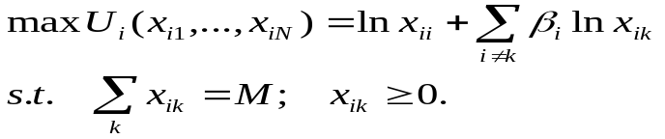(1)

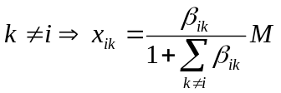Then the amount transferred from subject i to k, x_{ik} is calculated as follows:
(2)

For each relationship type, the top panel of figure 6 shows the amount transferred, the predicted transfer if it were based strictly on genetic relation, and the difference between the two. Note that each observation (N=556) is the amount of the transfer from the subject to another person in the group. In general, actual transfers do not equal predicted transfers, and most of the differences are statistically significant. The largest differences in the negative direction (actual less than predicted) are to identical twins and to other siblings. The largest differences in the positive direction (actual much greater than predicted) are to strangers, friends, and, especially, spouses.
Although we have increased the total money available to allocate as group size increases, it is possible that behavior may be affected by the number of potential recipients. To address that issue, the second and third panels show results for subjects in 8-person and 4-person groups separately. These results are very similar to what we see for the full group.
It is also interesting to observe how much the subject kept for herself, and how that differed when both the total money available to allocate and the number of potential recipients increased. Figure 7 gives a frequency distribution of dollars kept for self for those in 8 and 4 person groups. Although subjects in 8-person groups have twice as much money to allocate as those in 4-person groups ($200 v. $100), the modal dollars kept in both size groups is $20-30. There is greater dispersion (and a greater proportion of subjects who kept a higher amount), however, in the 8-person group.
Table 5 shows the results from regressions of money transferred as a function of the relationship coefficient and indicators of the type of donor-recipient relationship. Robust standard errors, accounting for multiple observations per person are calculated. The first column (sample is all transfers) shows that transfers increase by $12.21 when the coefficient of relationship increases from zero (strangers) to one (MZ twin). The results also show that within the group of genetically unrelated individuals (default category is stranger), transfers to a spouse are large and significant ($22.69). Transfers to friends are also significantly more than to strangers ($10.50). Finally, we see that the number of non-family members in the group increases transfers (by $0.84), implying that having more non-family members in the group increases the amount available to transfer to family members. Indicators of the sex and age composition of the donor-recipient pair are not significant.
The second column of Table 5 just replaces the relationship coefficient with a dummy variable indicating whether the donor and recipient are related, thus constraining the effect of genetic relatedness to be the same for all family members. The results from this specification are very similar to those from column 1. To test explicitly whether transfers to family members are a function of the degree of genetic relatedness, column 3 limits the transfers to those between family members (strangers and friends are eliminated, but spouses and other social categories of family members are retained in the sample). In that specification the relationship coefficient is no longer statistically significant (and the point estimate is small, but negative). This result suggests that what matters most is whether the donor and recipient are family members, not the degree of genetic relatedness within that group.
Column 4 eliminates 41 donors whose behavior is characterized by equal giving. Those results are very similar to the results in column 1, but the magnitude of the coefficients (especially the ones that are significant) is larger, suggesting that the presence of some equal givers partially masks the effects for the group whose transfer behavior depends, in part, on the degree of genetic and social relatedness. Finally, column 5 limits the sample to those in 8-person groups. Again, the results are very similar to column 1, but the magnitudes of the coefficients are larger, reflecting the greater total endowment for 8-person groups.
Table 6 presents regressions that control for the predicted amount, if transfers were based on Hamilton’s rule (equation 2), and specific types of donor-recipient relationship. Column one leaves out the predicted amount variable, providing a baseline for how transfers are affected by relationship status, independent of explicit measures of genetic relatedness. The reference category is adult to adult stranger. The relationship with the greatest transfers is between spouses who transfer $21 more to each other than they do to strangers. The next larger transfer group is between adult identical twins who transfer $13.82 more to each other than to strangers. It is interesting to note that transfers from adults to friends ($13.17) are almost as large as transfers between identical twins. The next largest transfer is from parents to children ($10.29). Although these decisions are completely independent and not revealed to the recipient, the parent child transfer is almost equally matched by transfers from children to parents ($9.46). Teens give about the same amount to their identical twin as they do to other siblings ($5), although the identical twin coefficient is not statistically significant. Finally, teen giving to miscellaneous relatives and to non-related individuals is not significantly different from the reference category of adult to adult stranger.
Column 2 includes the predicted amount, and in this specification, the relationship categories are then interpreted as deviations from the predicted amount. The results show that for every one dollar in predicted transfers, subjects actually transfer 28 cents. The relationship categories that significantly deviate from the predicted amount are adult to adult friend ($13 more than predicted) and spouse to spouse ($21 more than predicted). Column 3 eliminates the equal givers, and, as before, many of the coefficients increase in magnitude. Column 4 assesses the sensitivity of the results to group size and finds that the results for 8-person groups are essentially the same as in column 2 (again the magnitudes are larger, because the initial endowment is larger). Because some individuals or families might be more altruistic than others (or might have higher levels of resources outside the experiment, that would lead to greater giving), we control for individual and family fixed effects in columns 5 and 6. The basic results do not vary in these fixed effects models.
The final set of models (Table 7) adds some economic and demographic variables to the regressions and estimates the models separately for adults and teens. For adults, the relationship coefficient is significant, and is about the same magnitude as in Table 5. Similar to the previous results, giving to a spouse and to a friend is significantly higher than the reference category of giving to strangers. However, neither income, education, age, marital status or sex and age composition of the donor-recipient pair are significant. None of the variables in the teen regression are significant.

Comparison with Altruism Scales and Altruism Measures from Surveys
(results still to come)

Comparison of Giving to Family and Giving to Strangers
(results still to come)

Conclusions
In this paper we analyze the results from a multi-person dictator experiment to assess the importance of genetic and social relationships in altruistically motivated transfer behavior. Although a substantial minority (about a third) of participants made equal transfers to all persons in the group, transfer behavior of the remaining subjects is influenced by their social and genetic relationship to the potential recipient. The degree of genetic relatedness explains only part of transfer behavior. Several categories of relationships deviate significantly from what would be predicted on the basis of genetic relatedness alone. Specifically, higher transfers than expected are made between spouses and to friends and strangers and lower than expected transfers are made to siblings. In addition, there is some evidence of systematic individual and family specific effects on transfer behavior.

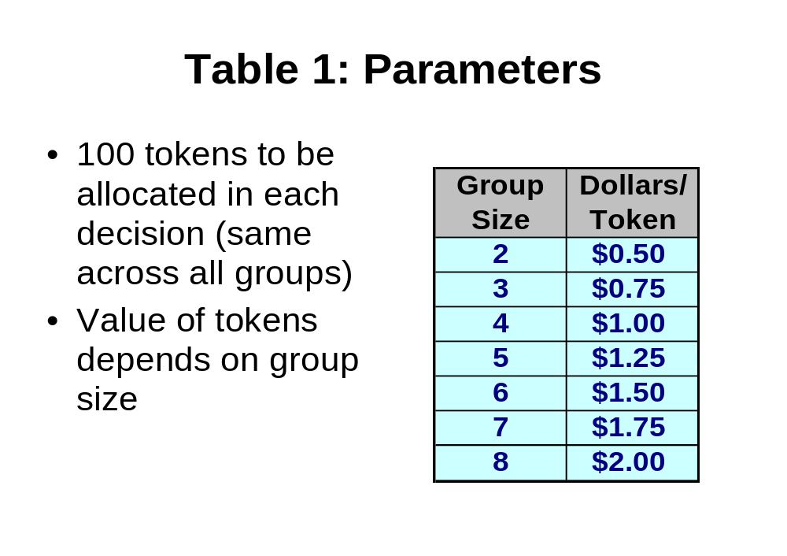
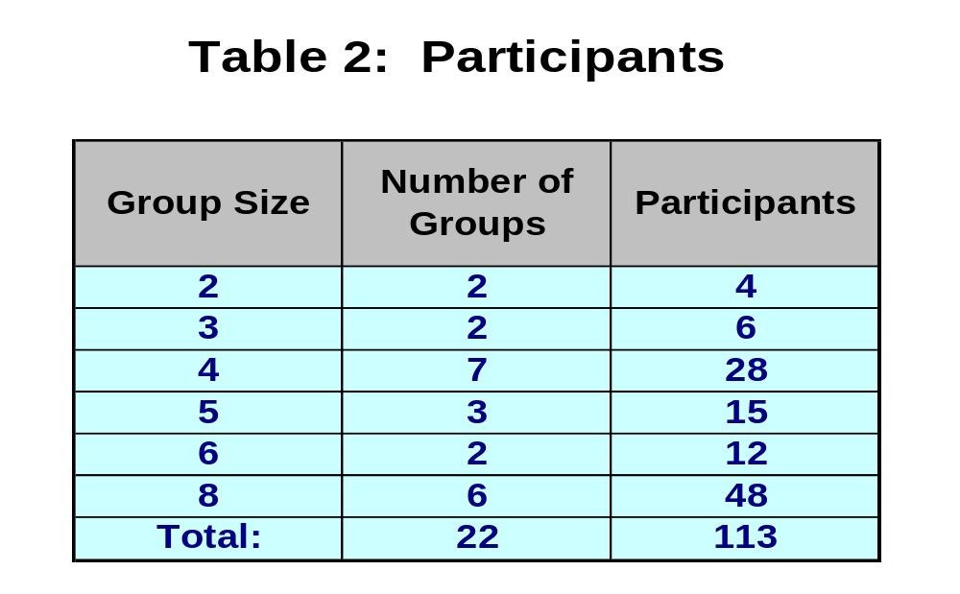

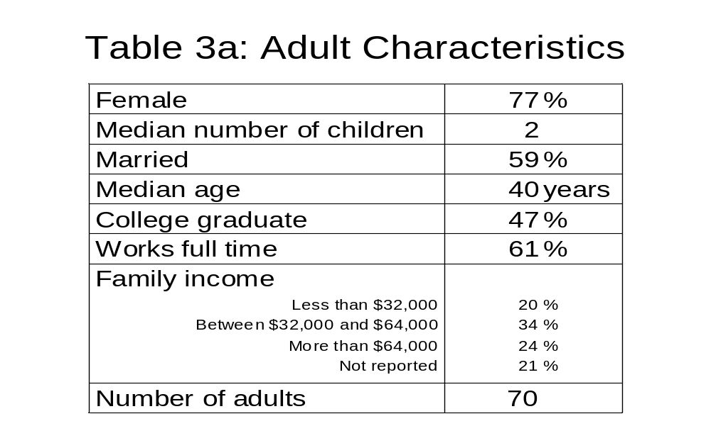

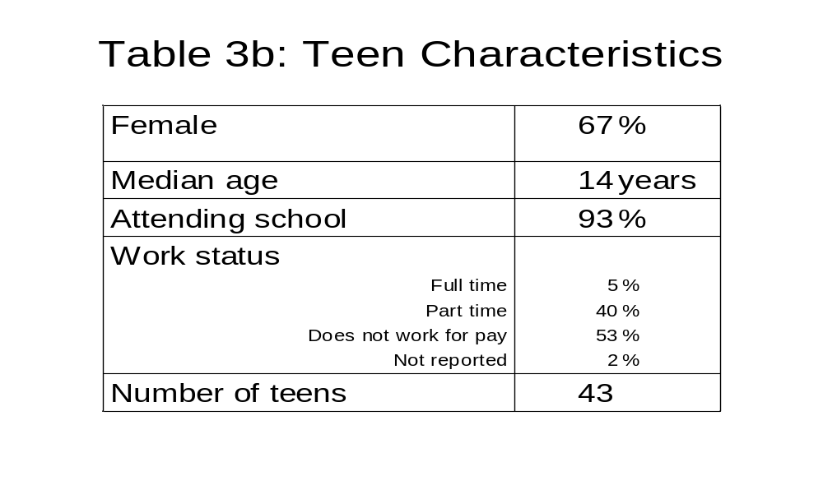

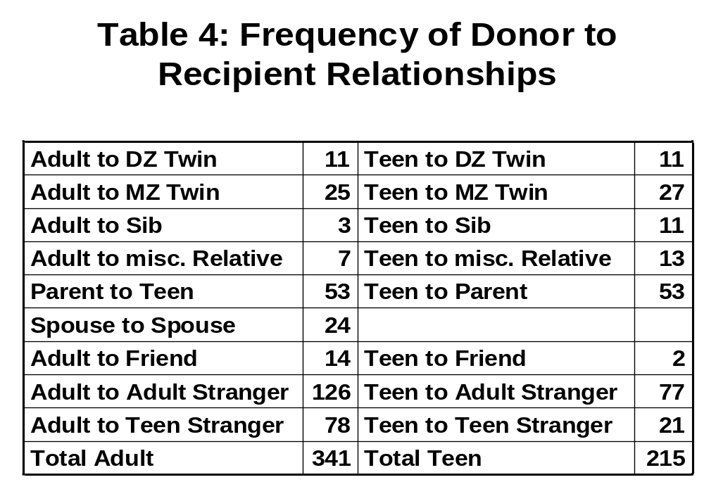

Table 5
 | All | All | Family Only | Eliminates Equal Givers | 8 Person Groups
Relationship Coefficient | 12.21 |  | -2.03 | 15.70 | 22.67
 | (3.368) |  | (5.383) | (4.484) | (5.033)
Is Related |  | 9.74
 |  | (2.578)
Female to Male | -2.42 | -2.36 | -3.28 | -2.85 | -3.24
 | (1.812) | (1.790) | (3.390) | (2.309) | (2.722)
Male to Female | -2.40 | -2.18 | -6.75 | -2.30 | -1.88
 | (2.085) | (2.219) | (4.391) | (2.783) | (2.581)
Male to Male | -2.33 | -3.50 | -3.76 | -2.44 | -7.43
 | (2.246) | (2.198) | (2.945) | (2.931) | (3.250)
Adult to Teen | 3.68 | 2.39 | -1.73 | 5.25 | 6.23
 | (2.219) | (2.113) | (4.742) | (2.944) | (2.977)
Teen to Adult | 2.53 | 1.57 | -4.66 | 3.92 | 4.22
 | (2.177) | (2.150) | (4.488) | (2.771) | (2.968)
Teen to Teen | -2.03 | -1.86 | -7.70 | -1.08 | -4.24
 | (2.145) | (2.139) | (4.564) | (2.669) | (2.827)
Spouse to Spouse | 22.69 | 23.22 | 10.28 | 32.74 | 28.16
 | (5.971) | (5.976) | (7.761) | (8.408) | (6.236)
To Friend | 10.50 | 10.24 |  | 13.82 | 20.26
 | (4.285) | (4.174) |  | (4.973) | (6.794)
Number of Family in Group | 0.48 | -0.07 | 1.11 | 1.10 | 0.42
 | (0.600) | (0.608) | (1.351) | (0.943) | (0.959)
Number of Non-family in Group | 0.84 | 0.99 |  | 1.50
 | (0.398) | (0.412) |  | (0.696)
Constant | 14.16 | 14.51 | 29.80 | 7.50 | 15.58
 | (3.126) | (3.019) | (5.021) | (5.568) | (2.379)
N | 556 | 556 | 238 | 412 | 336
Participants | 113 | 113 | 107 | 75 | 48
R-squared | 0.103 | 0.112 | 0.080 | 0.140 | 0.196
Joint p-value | 0.0001 | 0.0001 | 0.0076 | 0.0001 | 0.0000

Table 6

 | All | All | Eliminates Equal Givers | 8 Person Groups | Individual Fixed Effects | Family Fixed Effects
Predicted Amount |  | 0.28 | 0.39 | 0.20 | 0.33 | 0.26
 |  | (0.096) | (0.148) | (0.195) | (0.146) | (0.135)
Adult to Identical Sib | 13.82 | -4.13 | -10.30 | 8.69 | -12.76 | -8.26
 | (3.943) | (6.602) | (13.402) | (20.913) | (11.280) | (10.788)
Adult to Sib | 9.01 | -4.33 | -9.12 | 0.61 | -12.80 | -6.10
 | (4.263) | (6.241) | (10.761) | (11.635) | (10.190) | (8.221)
Adult to Misc Rel | 21.01 | 16.18 | 18.04 | 19.93 | 17.77 | 18.58
 | (7.916) | (8.231) | (10.212) | (9.137) | (8.662) | (7.310)
Adult to Teen Stranger | 2.94 | 2.94 | 4.33 | 4.41 | 2.61 | 2.37
 | (2.177) | (2.179) | (2.729) | (2.811) | (2.353) | (2.342)
Adult to Adult Friend | 13.17 | 13.17 | 16.31 | 18.64 | 20.66 | 19.86
 | (4.421) | (4.425) | (4.865) | (6.540) | (4.963) | (4.487)
Teen to Identical Sib | 4.76 | -11.42 | -16.54 | -6.46 | -28.01 | -3.56
 | (4.721) | (6.307) | (9.579) | (14.467) | (14.216) | (8.897)
Teen to Sib | 5.56 | -2.19 | -6.19 | 0.40 | -18.68 | 2.19
 | (2.522) | (3.484) | (6.091) | (12.337) | (11.340) | (6.222)
Teen to Misc Rel | 2.84 | -0.90 | 0.36 | -0.83 | -16.82 | 3.16
 | (2.350) | (2.820) | (3.535) | (5.006) | (9.925) | (4.375)
Teen to Adult Stranger | 2.84 | 2.84 | 4.31 | 3.70 | -11.00 | 7.94
 | (2.965) | (2.968) | (3.564) | (3.754) | (8.311) | (2.806)
Teen to Teen Stranger | 1.05 | 1.05 | 3.80 | 2.81 | -14.61 | 4.99
 | (2.935) | (2.938) | (3.124) | (3.204) | (8.605) | (3.351)
Teen to Friend | 1.27 | 1.27 | -2.86 |  | -19.53 | 3.30
 | (5.188) | (5.193) | (1.871) |  | (9.638) | (3.960)
Child to Parent | 9.46 | 2.51 | 2.51 | 14.90 | -12.80 | 9.27
 | (3.085) | (3.297) | (5.048) | (6.913) | (10.190) | (5.018)
Parent to Child | 10.29 | 1.65 | 1.45 | 14.68 | 7.95 | 8.49
 | (4.095) | (4.997) | (8.428) | (10.371) | (6.952) | (6.274)
Spouse to Spouse | 21.07 | 21.07 | 31.49 | 27.68 | 27.94 | 26.59
 | (5.623) | (5.629) | (7.964) | (6.055) | (5.630) | (5.288)
Constant | 16.85 | 16.85 | 14.11 | 14.49 | 21.56 | 14.10
 | (1.566) | (1.567) | (1.871) | (1.922) | (3.395) | (1.322)
N | 556 | 556 | 412 | 336 | 556 | 556
Participants | 113 | 113 | 75 | 48 | 113 | 44
R-squared | 0.118 | 0.148 | 0.196 | 0.250 | 0.204 | 0.184
Joint p-value | 0.0003 | 0.0002 |  | 0.0000 | 0.0000 | 0.0000

Table 7
 | Adults | Teens
Relationship Coefficient | 14.77 | 8.86
 | (4.522) | (5.248)
Income Less than $32K | -0.55
 | (2.229)
Income between $32K and $64K | -0.95
 | (1.473)
Income more than $64K | -1.43
 | (1.830)
Female to Male | -2.10 | -3.60
 | (2.875) | (2.652)
Male to Female | -3.19 | 0.67
 | (2.906) | (2.872)
Male to Male | -4.46 | -0.03
 | (3.275) | (2.673)
Adult to Teen | 3.75
 | (2.306)
Teen to Adult |  | 4.43
 |  | (2.806)
Is Friend | 13.33 | 4.38
 | (5.343) | (6.640)
Spouse to Spouse | 25.00
 | (6.800)
Age (years) | -0.12 | -0.47
 | (0.082) | (0.571)
Is Married | 0.01
 | (1.906)
Education (years) | 0.27
 | (0.251)
Number of Family in Group | 0.14 | 2.10
 | (0.756) | (1.369)
Number of Non-family in Group | 0.54 | 1.57
 | (0.425) | (0.796)
Constant | 16.61 | 13.11
 | (4.594) | (10.072)
N | 339 | 214
Participants | 69 | 43
R-squared | 0.168 | 0.043
Joint p-value | 0.0142 | 0.0435

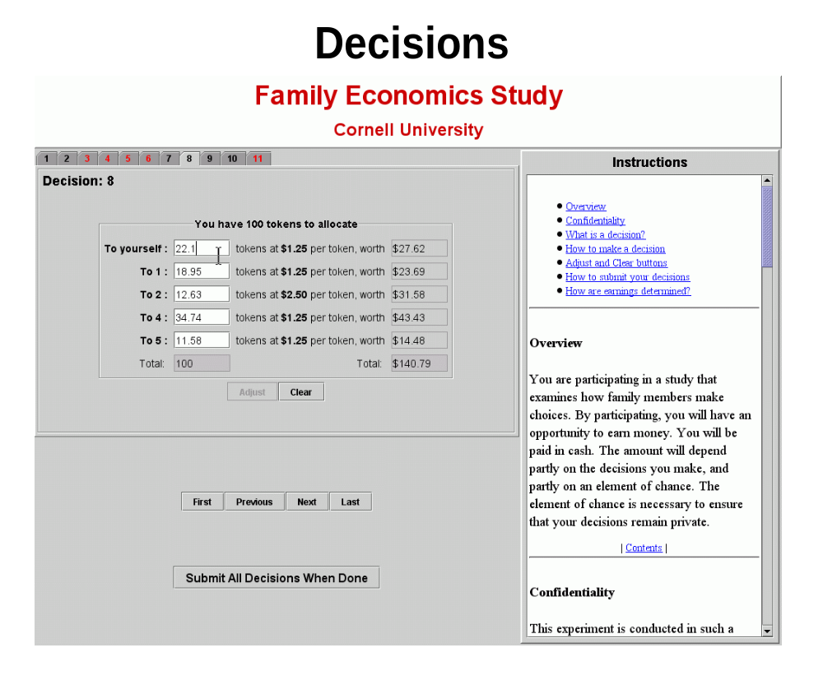
Figure 1
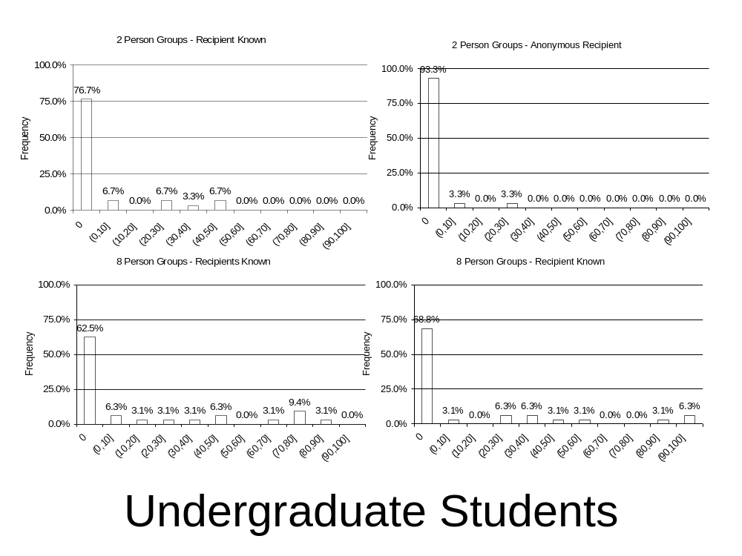
Figure 2

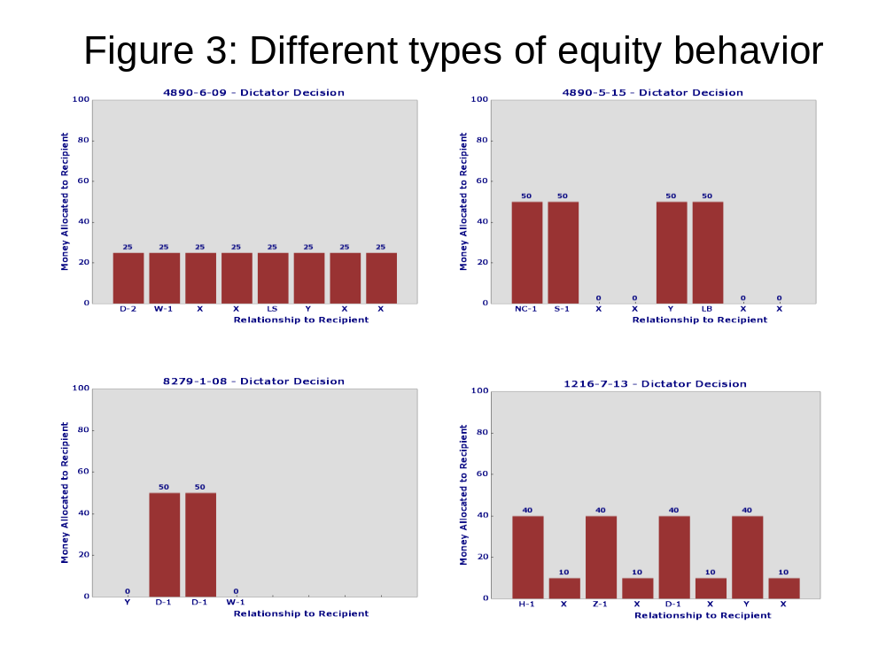
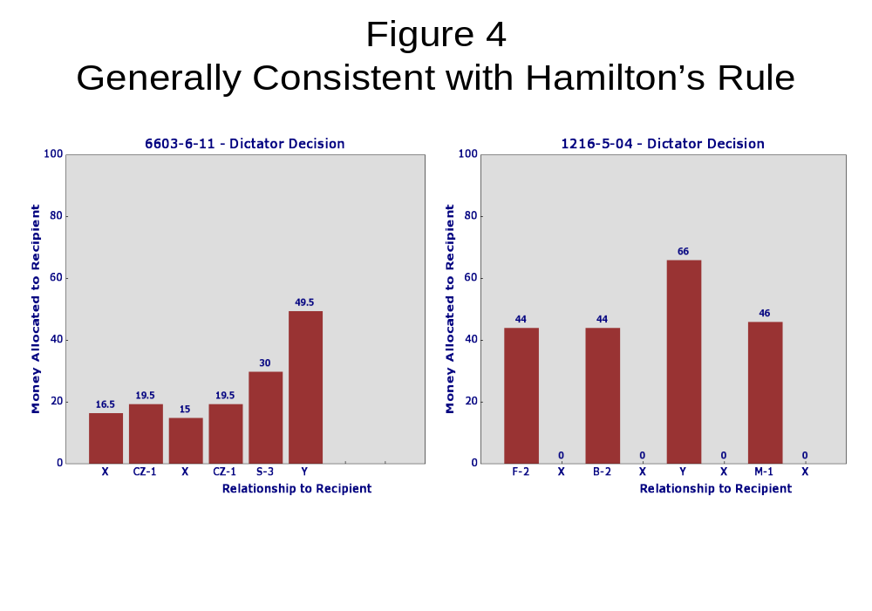

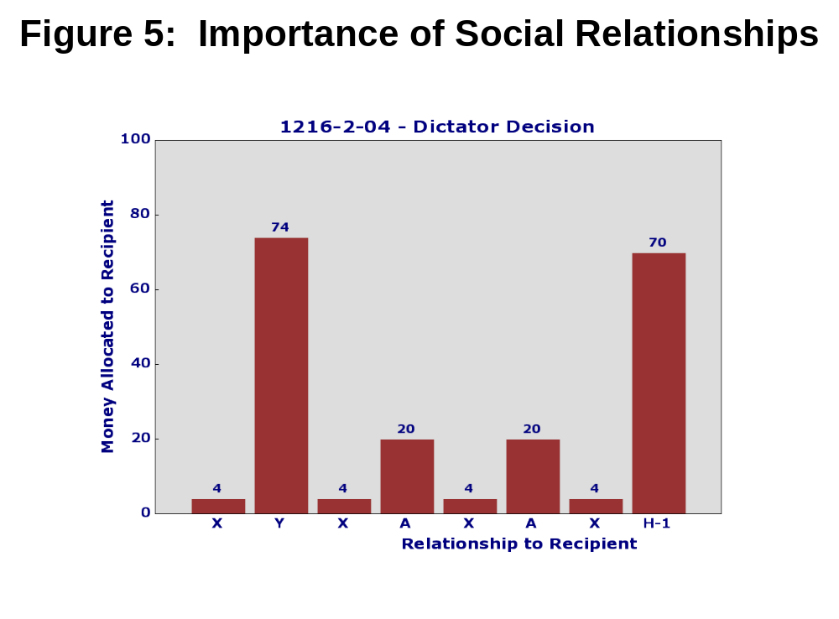

Figure 6
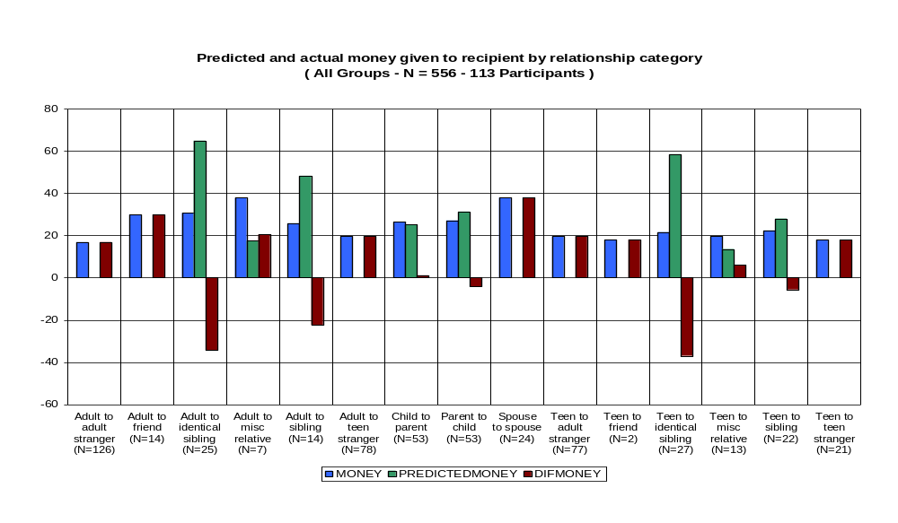
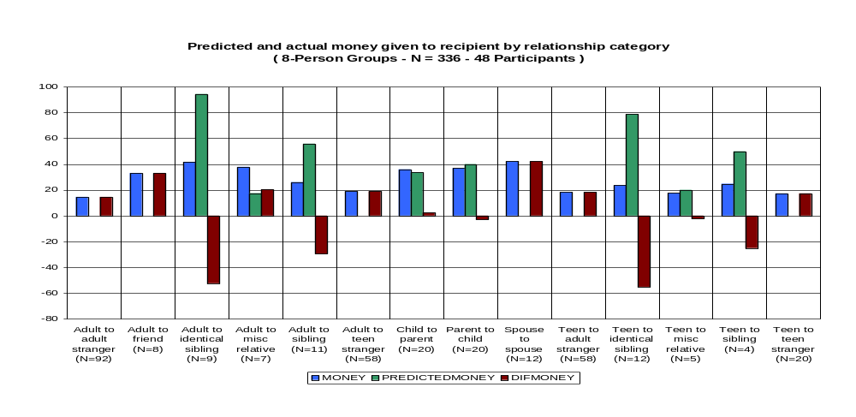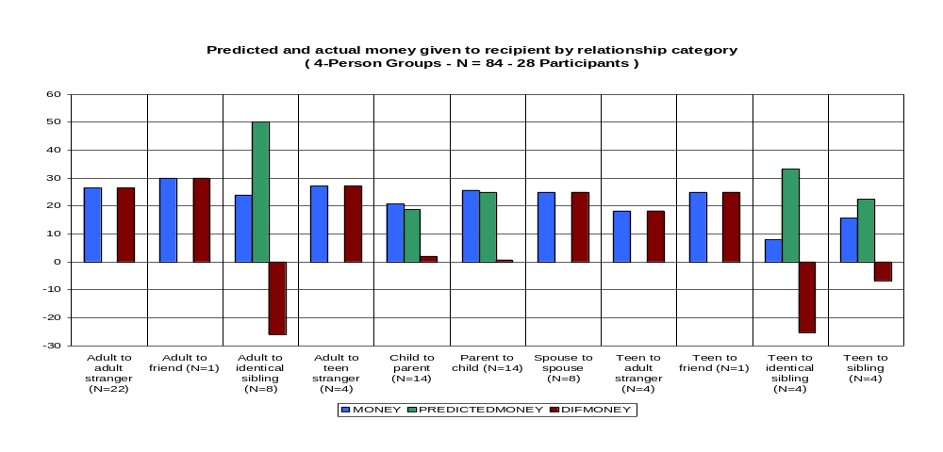
Figure 7
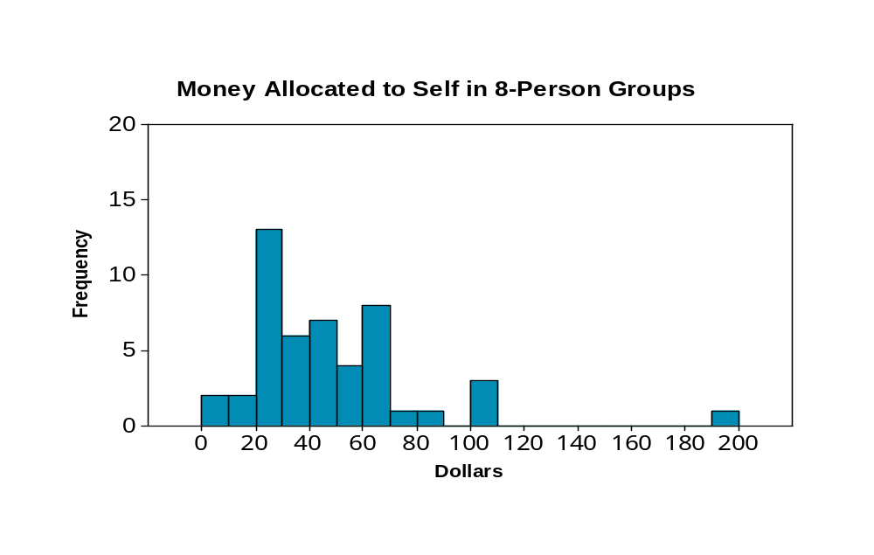
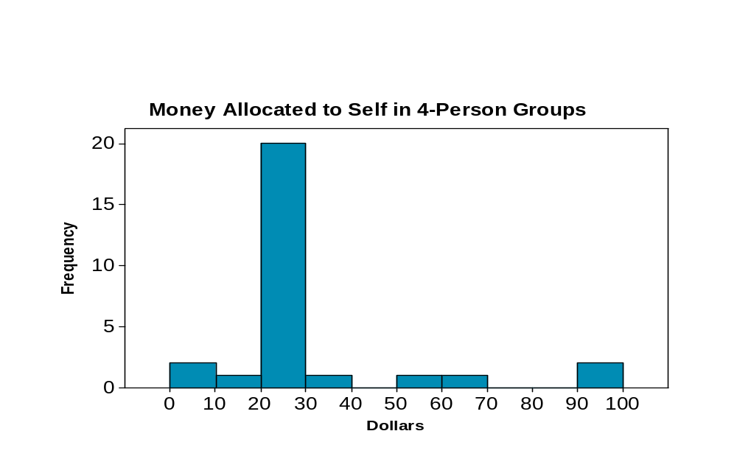
References
49
Andreoni, J. & Miller, J. H. (2002), Giving according to GARP: An experimental test of the consistency of preferences for altruism, Econometrica 70, 737-753.

Ashenfelter, O. & Krueger, A. B. (1994), Estimates of the economic returns to schooling from a new sample of twins, American Economic Review pp. 1157-1173
.
Ashenfelter, O. & Rouse, C. (2000), Schooling, intelligence, and income in America, in K. Arrow, S. Bowles & S. Durlauf, eds, Meritocracy and economic inequality, Princeton University Press.

Becker, G. S. (1974), A theory of social interactions, Journal of Political Economy 82, 1063-1094.

Becker, G. S. (1991), A Treatise on the Family, Harvard University Press.

Bergstrom, T. C. (1989), A fresh look at the Rotten Kid Theorem and other household mysteries, Journal of Political Economy 97, 1138-1159.

Bergstrom, T. C. (1995), On the evolution of altruistic ethical rules for siblings, American Economic Review 85, 58-81.

Bergstrom, T. C. (2000), Evolution of behavior in family games, UCSB Working Paper.

Bergstrom, T. C. (2002), Evolution of social behavior: Individual and group selection, Journal of Economic Perspectives 16, 67-88.

Davis, M. H. (1980), A multidimensional approach to measuring individual differences in empathy, JSAS Catalog of Selected Documents in Psychology 10, 85.

Davis, M. H. (1983), Measuring individual differences in empathy: Evidence for a multidimensional approach, Journal of Personality 44, 113-126.

Davis, M. H. (1994), Empathy: A Social Psychological Approach, Westview Press, Inc., Boulder, Co.

Forsythe, R., Horowitz, J. L., Savin, N. E. & Sefton, M. (1994), Fairness in simple bargaining experiments, Games and Economic Behavior 6, 347-369.

Hamilton, W. D. (1964), The genetic evolution of social behavior, Journal of Theoretical Biology 7, 1-52.

Hoffman, E., McCabe, K., Shachat, K. & Smith, V. (1994), Preferences, property rights, and anonymity in bargaining game', Games and Economic Behavior 7, 346-380.

Hoffman, M. L. (1975), Altruistic behavior and the parent child relationship, Journal of Personality and Social Psychology 31, 937-943.

Peters, H. E., Uniir, A. S., Clark, J. & Schulze, W. D. (2004), Free-riding and the provision of public goods in the family: A laboratory experiment, International Economic Review 45, 283-299.

Rushton, J. P., Chrisjohn, R. D. & Fekken, G. C. (1981), The altruistic personality and the self-report altruism scale, Personality and Individual Differences 2, 292-302.

Ünür, A. S., Peters, H. E. & Schulze, W. D. (2004), Incentive effects of parents' transfers to children, Department of Policy Analysis and Management, Cornell University.

Bergstrom (1995, 2000, 2002) has done extensive work exploring connections between biology and altruistic behavior in economic games.
The software had participant and control components. The screenshot shown here is from the participant component. Both components were implemented as standalone Java applications. Details and source are available upon request.
The computer interface also displayed a copy of the printed instructions given to participants. The text of the instructions can be found in the appendix.
About a third of participants allocated equally across all members of the group (including self), and another 9 percent exhibited some other type of equal division behavior.
Cases where the differences are not significantly different from zero include child-parent and parent child transfers (all, GS=4, GS=8); teen-friend (all); teen-miscellaneous relative (all, GS=8) and teen-sib (all, GS=4).
The category adult to miscellaneous relative also has large transfers, but this is based on only 7 observations, so it is not clear how to interpret this result.

