Psych./Neuro. 201
Creating Figures in Microsoft Excel (for the Macintosh)

If you decide to use a figure in a paper, you should create it using Excel or another similar program. Creating a figure in Excel is very easy. For instance, let’s imagine that I wanted to graph the data from the example we used in class for the one-way ANOVA. Recall that the three conditions were (1) criminal record, (2) clean record, and (3) no information, and that the DV was a rating from 1 (completely sure of defendant’s innocence) to 10 (completely sure of defendant’s guilt). [Note: Example for two IVs is on p. 5.]

In Excel, I would type the mean of each group into a spreadsheet, as shown below:

Note that I have included the heading for each level of the IV. If I had more than three levels of the IV, I could continue adding rows. I could also have presented the information in three columns rather than in three rows; it doesn’t matter. You can always change it once you’ve created the graph by double-clicking on the graph and choosing “Switch Row/Column” from the Chart Design toolbar.

Next, highlight all six cells and go up to the “Insert” tab. You’ll get the options shown below. Choose the icon that looks like a column bar graph (I’ve circled it below).

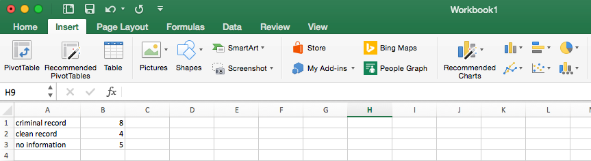

You will then see a variety of column chart types, as shown below. Click on Clustered Column (top left option).
In APA-style, we don’t include a chart title, so you can click on the box that reads “Chart Title” and delete it.

We do, however, need to label our axes. To do so, click on your chart and you will see the menu options below.

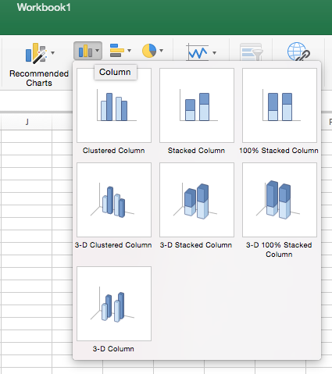
Your bar graph will then appear as part of your spreadsheet, as shown in the figure to the right.

Select the “Chart Design” tab and then choose “Add Chart Element” (all the way to the left). You will see the following options:

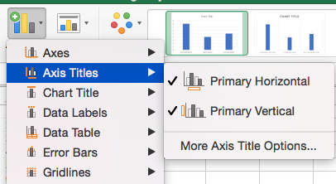
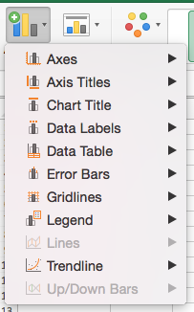
Select “Axis Titles” and then “Primary Horizontal.” This will create a text box below your figure where you can type in your x-axis label (I typed “Experimental Condition”). You can then select “Primary Vertical” and type a y-axis title. I chose “Mean Rating of Defendant’s Guilt.” It is very important to label your axes. Be sure to capitalize all major words in your axis titles.

You can play around with the formatting of the figure. For APA-style papers, your bars should be black or grey. To change bar colors, simply double click on a bar. You will then see the box below on the left.

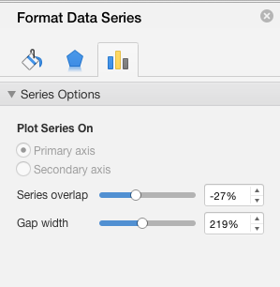
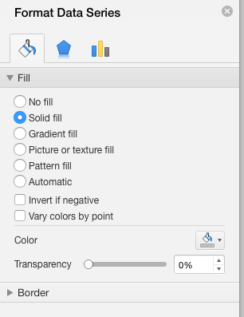
Choose the left-most icon to change bar colors.
Then select the “Color” option (as indicated to the left), click on the drop-down for “Fill,” select “Solid fill,” and then choose your preferred bar color.

You can also adjust the scale of your y-axis by either double-clicking on it or by choosing the “Axes” option on the toolbar and selecting “More Axis Options” (see box below, left). Either way will bring up the “Format Axis” dialog box shown below, right.
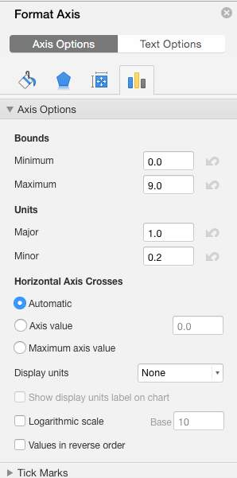
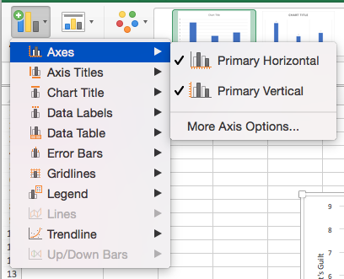
For this example, the rating scale ranged from 1-10, so a y-axis value of 0 is not appropriate. To change the scale, change the minimum to 1 and the maximum to 10.

In other cases, you might want the minimum to be zero.

Other chart features can be changed via the “Add Chart Element” option. If your figure requires a legend (as it does if you have more than one IV), you can choose its position (e.g., top, bottom, left, right) here under the “Legend” option. You can also select the “Gridlines” option to remove the horizontal gridlines if you wanted to (your choice).

You can also play around with the font sizes. If you click in the upper left-hand corner of the chart, you can select the entire chart, and then click on the “Home” tab to change the font and sizes of all text that appears in the chart. As a rule, you should use a sans serif font (such as Helvetica or Arial) for figures. I usually use 14-point font for my axis titles (though I’ve squashed some of the figures in this handout to make them fit on the page!).

APA style requires that you remove the border around the figure. To do so, double-click on the border to bring up the “Format Chart Area” dialog box you used before for changing the bar colors. This time, select the “Border” option and choose “No line” instead of “Automatic”.

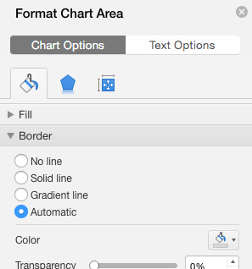

To get the figure into your Microsoft Word document, click on the figure in Excel, select Copy (command-C), choose “Paste Special” from the Edit menu in Microsoft Word, and then choose “Paste as pdf.” You can resize the figure by dragging it from a corner (don’t drag it from an edge or you will stretch or squeeze it). You might need to double-click on the picture of the figure, select “wrap text” from the menu bar, and then select “square” or “in front of text” to get the picture to stay put.

You can then type the figure number and title, as shown below. The words “Figure 1” are in bold and the title, double-spaced beneath the figure number, is in italics with upper- and lower-case letters.

Figure 1

Mean Guilt Rating as a Function of Condition

Adding Error Bars

Often, it is useful to include in your figure error bars that indicate one standard error (standard error, NOT standard deviation) above and below the mean for each level of the IV. Doing so gives your viewer a sense of the variability of the data. To create the error bars, you simply type the standard errors into the spreadsheet, as I’ve done below for our example (you can find the standard errors on the SPSS printout):

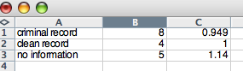
Click on the figure, go to “Add Chart Element,” select “Error Bars,” and then “More Error Bars Options…” (as shown below):

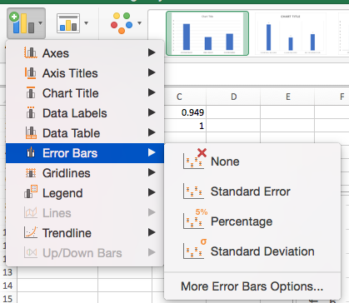
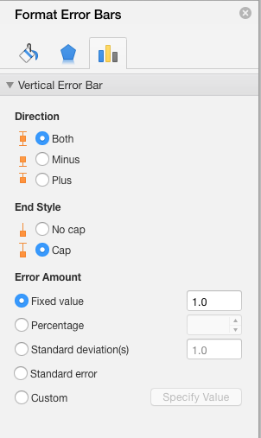
You’ll get the dialog box shown to the right. Choose “Both” under the Direction option (this is the default). This will give you error bars depicting one standard error above and one standard error below the mean. Then choose “Cap” for the error bar style. Under Error Amount, click on the button labeled “Custom,” then “Specify Value.” You’ll see the dialog box below.

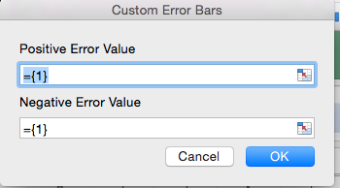

Click in the box next to “Positive Error Value.” In the spreadsheet, highlight the three boxes with the standard error values you inputted. They will automatically appear in the white box. This will create the line indicating one standard error above the mean. Hit enter. Repeat this process in the white box next to “Negative Error Value” (to create the line indicating one standard error below the mean), click enter, and then click OK.

The new bar graph appears below. Note that in order to make the error bars stand out, I changed the bar colors to light grey and removed the horizontal lines on the graph. As per APA style, you should include a figure note beneath the figure to specify what the error bars represent.

Figure 1

Mean Guilt Rating as a Function of Condition

Note. Error bars represent one standard error above and below the mean.

Creating Figures When There is More Than One IV
Imagine that I conducted an experiment very similar to the first, only now I was interested in whether an additional factor—gender of the defendant—also played a role in guilt ratings. My design would now be a 3 (prior information: criminal record, clean record, no information) x 2 (gender of defendant: male or female) factorial design. (Assume no defendants reported being transgender or non-binary.) I have two independent variables, one with three levels and one with two levels.

Imagine that my new means and standard errors are as follows:
Notice that I’ve typed the “male” and “female” headings in the second and third columns. I could also have put male and female down the left column and the levels of the other variable across the top row; it doesn’t matter. How can I represent these data in a bar graph?

Again, highlight all the cells with means (including the headings) and follow the same instructions as before to create a clustered column chart. When you see a preview of your figure, you’ll notice that the different criminal record conditions are displayed along the x-axis, and that gender of defendant appears in the legend (one bar for male and one bar for female at each level of the other variable). I think this format makes sense for these data, but if you wanted to reverse the placement of these variables (e.g., have gender of defendant along the x-axis and the other variable in the legend), you could go to the “Chart Design” toolbar and select “Switch Row/Column.”

For some reason, this new version of Excel makes the male and female bars at each level of the criminal record IV not touch each other. To make the bars touch, go to the “Quick Layout” menu and pick the image you like best (with bars touching). You may have to make some adjustments to get rid of other features of that layout you don’t want (e.g., the means written at the top of the bars or a chart title).
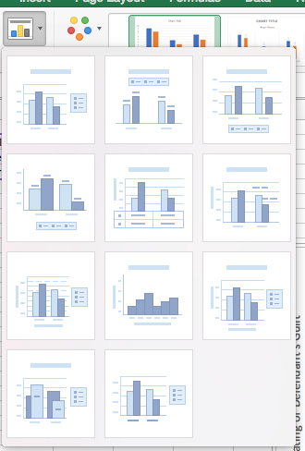
Now you can make all the same adjustments as you made for the earlier example (e.g., deleting the border, changing the font & size, labeling the axes, changing the bar colors, changing the scale of the y-axis, adding error bars). Note that you’ll need to make two columns of error bars, one for male and one for female. When you add the error bars for the “male” or “female” bars, make sure you’re selecting the correct row of standard errors.

Go to “Add Chart Element” and “Legend” to choose the placement of the legend.

Now that you have two bars at each level of the criminal record IV, you should create bars of contrasting colors, still using shades of grey (to allow for the error bars to show up). Below is my completed figure.

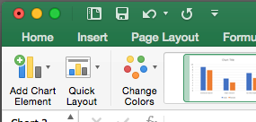

Figure 1

Mean Guilt Rating as a Function of Condition and Gender of Defendant
That’s it! If you can’t figure something out, use the Excel “Help” menu. Have fun!

Note. Error bars represent one standard error above and below the mean.

