Psych./Neuro 201 (Statistics & Research Methods in Psychology)
Creating APA-Style Tables in Microsoft Word

A table can be an efficient way of communicating a lot of information in a small amount of space. It should be able to stand on its own, and should not be redundant with material presented in the text of your paper. It is not difficult to create a table in Microsoft Word, but there are a few tricks to making it conform to APA style. See pp. 201-224 of the Publication Manual of the APA (7th ed.) for sample tables in APA style. Below are the basic elements of an APA-style table.

The Elements of an APA-Style Table

- Table number (in bold). Tables are numbered with Arabic (i.e., regular) numerals in the order they appear in the paper.

- Table title (italicized). The table title should be one double-spaced line below the table number. Capitalize the first letter of major words, and do not end with a period. The title should be descriptive, but succinct.

- A horizontal line separates the table title from the column headings.

- Column headings (labels centered over each column). Use upper- & lower-case.

- A second horizontal line separates the column headings from the table data.

- Data for your table go next. The table can be double-spaced or not, depending on how much information you need to convey.

- End your table with a final horizontal line beneath the last row of data. The three horizontal lines listed above are the only three lines you should have in your table. You should not have any vertical lines.

- Table notes go one double-spaced line beneath the final horizontal line. Begin with the word Note (in italics) followed by a period. General table notes are used to explain abbreviations or provide additional information. (See pp. 203-204 of the APA manual for an explanation of general, specific, and probability notes, and how to format them.)

A Sample Table

Below we will walk through an example for a simple table of means and standard deviations. The table represents respondents’ average enjoyment rating for a variety of activities.

First, we need to think about how we want to organize all this information. This is the most important step in creating a good table. Sketch it out for yourself before beginning. It makes sense to list all the variables down the left-most column, and then have two more columns next to that one, one for the means and one for the SDs.

The table below is formatted in APA style. Following it are instructions for how to create it in Microsoft Word. Notice that there is a table “Note” in which relevant information is described (e.g., the score range of the variable(s), significance).

Table 1

Rating of Enjoyment of Different Activities

Activity | M | SD
Attending class  Sports/working out  Socializing  Watching television  Extracurricular activities  Volunteer work  Working (job) | 5.32  5.17  6.51  3.63  5.86  6.13  2.56 | 1.59  1.23  1.03  2.54  2.12  0.49  2.10
Note. All items were rated on a scale from 1 (do not enjoy at all) to 7 (greatly enjoy).

How to Create the Table in Microsoft Word

First, click on the “Insert” tab near the top of the screen and click on the arrow next to “Table”. You can then select the number of columns and rows you want in your table. Here I selected 3 columns (one for the variable name, one for mean, one for SD) and 2 rows (one for the header row and one for the data rows).

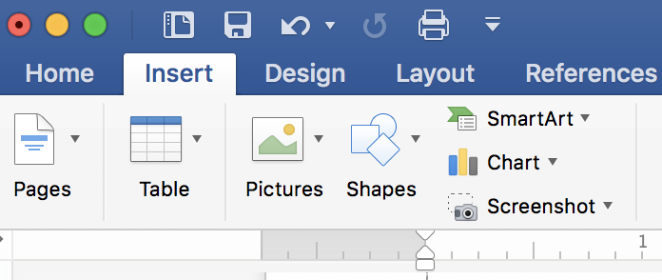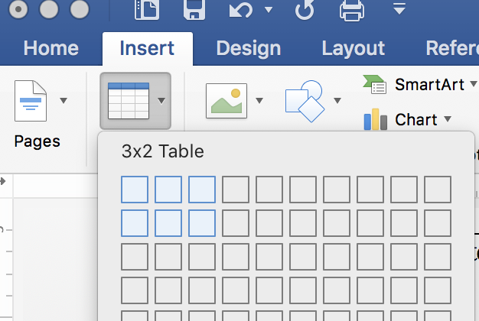

If you are not yet sure how many rows or columns you need, it is easy to add or delete them later by clicking within your table, selecting the “Layout” tab, and choosing to insert or delete rows or columns (note the left/right, top/bottom options relative to your cursor or current selection).

You will then get the basic table shown below:

Obviously, this table is not in APA-style format. In APA style, tables should have only horizontal and no vertical lines. To fix the table rules, click on the “Table Design” tab and find the “Borders” option near the top right of the screen:

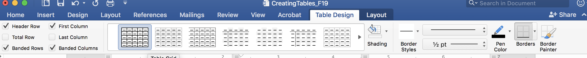

Select your entire table and click on the arrow next to where it reads, “Borders”. Choose “none”. Now you can go back in and select certain rows of your table and choose a top and bottom border, where applicable.

Your table should now look like this:

Now you are ready to begin entering your variable names and data into the table. Just place the cursor into the table cell and type. Tab to move to the next cell in the table. Below are a few handy tips:

- Use the centering function (under the Layout tab) to center your table headers. Left-align the variable names in the left-hand column. Note that you should never try to space anything using the space bar (the “eyeball” method). Even if it looks correctly aligned on the screen, it will not be correct when you print the table out.

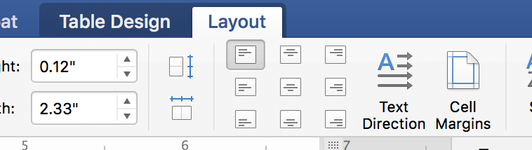
- Be sure to align your numbers by the decimal point. To do so, first go up to “View” and choose “Ruler”. You should now see the ruler at the top of the screen. Select the appropriate table columns by highlighting them, and go up to the top left-hand part of the screen, where the various tabs are displayed (see below):
Choose the decimal tab by clicking on the tab box until the one pictured at the left appears. Now click on the ruler where you want the decimal tab to appear (i.e., in the center of the column). Doing so for one column will place that tab in the same spot in all highlighted columns. Now, when you type numbers into the table, they will align automatically. If you do need to tab over within a column, hold down the “option” key while hitting the tab key.
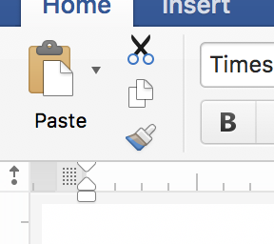

Note that tables of means and standard deviations are most common, along with tables of frequencies (percentages). In general, psychologists do not produce tables of modes (or even medians). That should get you started! Remember that you can always use the “Help” function in Microsoft Word (or Google for help….) if you run into trouble.

A Second Sample: Correlations Table

With only three or four variables, you can use variable names in the row and column headers. However, if you have a lot of variables, you should number them in the row labels (left-hand column) and then use numbers instead of variable names as the column headers, to save space.

Place dashes along the diagonal where each variable is correlated with itself, and place the Pearson r values below the diagonal. Use asterisks in the table to designate the significance of your correlations and define them beneath your table in the Note (see example below). Leave the cells above the diagonal blank. General practice is to include means and SDs columns for each variable, as shown below.

Table 2
Descriptive Statistics and Correlations
Measure | 1 | 2 | 3 | 4 | 5 | 6 | M | SD
1. Stigma Consciousness | — |  |  |  |  |  | 3.37 | 0.61
2. Self-perceived dominance | - .14 | — |  |  |  |  | 3.06 | 0.57
3. Self-perceived creativity | - .21 | .49** | — |  |  |  | 3.03 | 0.68
4. Self-esteem | - .33* | .51*** | .48** | — |  |  | 7.38 | 1.85
5. Nonverbal dominance | - .02 | .27* | .22 | .28* | — |  | 3.21 | 0.73
6. Yielding | - .34* | - .18* | - .02 | - .07 | .05 | — | 0.11 | 0.10
Note. Stigma consciousness scores ranged from 0 to 6; self-perceived dominance, self-perceived creativity, and nonverbal dominance scores ranged from 1-5; and self-esteem scores ranged from 1-11. Yielding = the number of times per minute the participant yielded to the confederate’s ideas. * p < .05. ** p < .01. *** p < .001.

